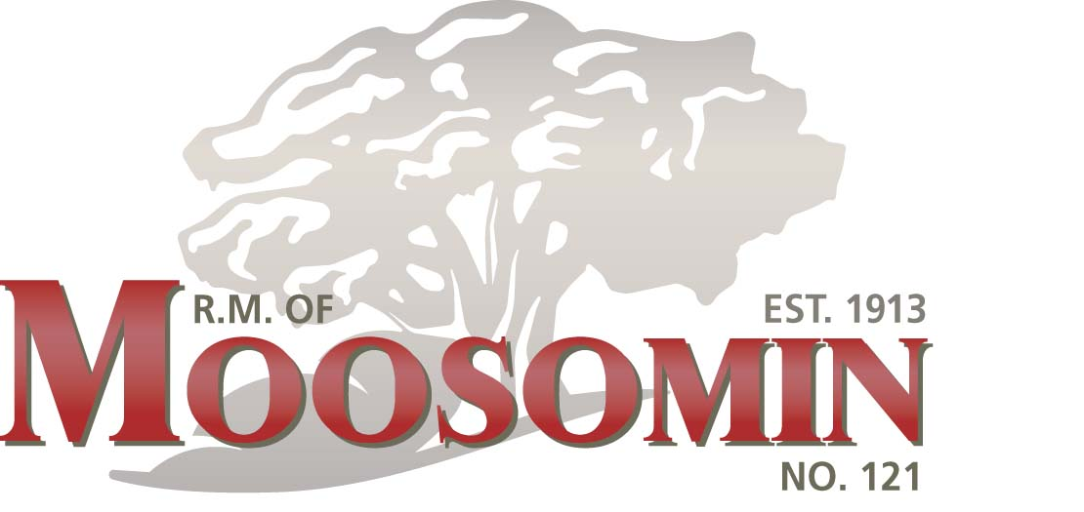
2024 Newsletter

2019 Newsletter

Office Contact Information:

Administrator: Kendra Lawrence
Address: Box 1109 Moosomin, SK
S0G 3N0
Phone: 306-435-4950
Fax: 306-435-4313
Email: cao@rmofmoosomin.com
Website: www.rmofmoosomin.com

Office Hours:

Monday to Thursday
8am - 12pm and 1pm - 4pm

Council Members:

Reeve: David Moffatt - 435-9245
Div. 1 Jeff McMullen - 435-7847
Div. 2 Rob Hanson - 435-8020
Div. 3 Herb Doll - 434-7643
Div. 4 Mark McCorriston- 435-6811
Div. 5 Dale McAuley - 435-6840
Div. 6 Ernest Dobson - 435-9591
Div. 7- Vern Hamilton – 434-6653

ELECTION DAY (DIVISIONS 1, 3, 5, 7 & REEVE)
WEDNESDAY, NOVEMBER 13, 2024
Every two (2) years there are Municipal Elections. The 2024 elections will be for Councillors of Divisions 1, 3, 5 and 7 and Reeve on Wednesday, November 13, 2024. The term of all members of Council is four (4) years. The Nomination Period will begin when the Returning Officer publishes the Call for Nominations in the paper in late August/beginning of September. Nominations may be filed during regular office hours from the time of the Call for Election to the deadline of 4 pm on Nomination Day (Wednesday, October 09th). To be eligible to run for Council you must be at least 18 years of age, a Canadian citizen, eligible to vote in the Municipality and a resident of Saskatchewan. You are required to complete a Public Disclosure Statement and it must be submitted with Nomination Paper.

Serving on a Municipal Council can be an eye-opening experience. There are many good reasons for running for Council: you would lead change in the municipality and be actively involved in the decision/policy making of the Municipality, address issues relevant not only to our Municipality but all rural municipalities, contribute your experience and knowledge to the community just to name a few. As an Elected Official you will be entrusted to make decisions that affect the daily lives of the ratepayers of our Municipality. A Council’s main purpose is to provide leadership and make policy. A municipal council makes decisions collectively – Council as a whole (based on a majority vote) make the decisions after carefully weighing all pieces of information available. Decisions/Policies of Council are made by either passing a resolution or enacting a bylaw and then the administrator implements the decisions/policies.

If elected you should plan to attend monthly Council Meetings (generally the 2nd Tuesday of each month), special council meetings as required, committee meetings and possibly conventions, workshops, and training. Councillors receive renumeration (payment) for their attendance.

If you are interested in running for Council you may wish to check out the following websites:

https://www.saskatchewan.ca/government/municipal-administration/elections/running-for-municipal-office

https://www.saskatchewan.ca/government/municipal-administration/tools-guides-and-resources/information-for-council-members

Council Meetings:

Council meetings are generally held the second Tuesday of each month at 8:30 a.m. in the Municipal Office in Moosomin.

If you would like the opportunity to speak to council, please make an appointment by contacting the office at least one week before the date of the meeting.

Public Works Information:

Construction Crew –
Darcy Jamieson & Dave Osbourne

Maintenance Foreman -
Bobby Stevens
Maintenance– Blake Kennedy
Maintenance- Faron Gibson
Water Operator/Supervisor
Amber Hamilton
Waste Water- Carl Bowey

Permits are

ELECTIONS 2024

ANNUAL REMINDER
Passing Municipal Equipment/Workers- We request that when passing municipal equipment and workers that your speed be reduced to 60km/h. IT IS THE LAW!! Section 203 (1)(c) of the Traffic Safety Act states that: “ No person shall drive a vehicle on a highway at a speed greater than 60 kilometers per hour when passing… (c) any highway equipment on a highway that has ministry issued warning lights in operation, whether in motion or not” This means gravel road and municipal equipment with flashing lights!!

Wells- Reminder of Yearly Notification for Users of Non-Potable Wells
Please be advised that the health region no longer monitors the bacteriologic water quality of Non-potable wells. Therefore, water from municipal wells in the R.M., available to the public, are not treated or tested and is considered unsafe for human consumption. DO NOT USE this water for drinking, cooking, food preparation and oral hygiene purposes

Controlled Burn – 1-866-404-4911 – if you are planning a controlled burn call the number so you are not billed for a fire call. The number is answered 24/7- 365 days a year.
If there is a FIRE BAN issued by the municipality and you burn you will be charged with a fire call (if fire department responds) and a fine. Most importantly DID YOU KNOW ….. you are NOT covered by your insurance and could be liable for any damages that occur as a result of that fire.
Notices are posted to the website www.rm121.com , sent via email to anyone that has submitted the email consent form and to the RM’s facebook page.

Keep in mind when burning that fire guards should be in place before burning. A water source and other means of extinguishing the fire should it get away, it should also remain under constant supervision until burn is complete.

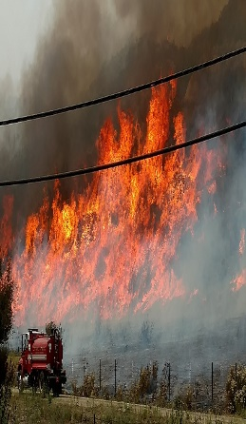
DID YOU KNOW

Gravelling - The R.M. does not accommodate private gravelling of lanes or yards. Please contact private contractors for your project needs.

RM Maps – Maps are available from the office at $16.00/map. Newly updated and printed June 2022

Mowing- Has begun and we ask that you ensure gates are swung into your property to prevent damage to your gate and municipal equipment.
Note for next year- IF you wish to cut ditch hay please contact the office before June 15th to let us know.

Snow Pushing/Ridging- Snow cannot be pushed out onto the municipal roads it causes safety issues for traffic. Please keep it to your own property.

Facebook/Website – The municipality has both a website www.rmofmoosomin.com and a facebook page to assist in providing up to date notice of events, notices, bans etc.

Legion Hall – Division 7 – is available for rent anytime for $50.00. Contact the office to book a birthday party, wedding anniversary or other event where space at home is just not enough.

This Photo by Unknown Author is licensed under CC BY-SA
Development permit

.

-Every person shall apply for a development permit before commencing any development within the municipality, so that Site and Building Setback Requirements of the Zoning Bylaw are being met.
(i.e.: all farm buildings- grain storage, machine sheds, residence or additions to, linear public utilities, and oil wells to name a few)

Building Permits

The municipality has contracted the services of Muniode Services as its’ building official. Building permits must be applied and approved for
country residential homes and light and heavy commercial/industrial. Plans of the development must accompany the application and
inspections will be completed by the building official periodically throughout the construction process.

